Graded Exercises on Trees
Important notes:
- You are NOT allowed to use any auxiliary array-like or linked-list-like storage data structures, not even stacks, queues, nor “strings”.
- Manual penalty will be applied to your grade if you violated the above implementation constraints or the mentioned constraints in the attached code file.

Problem 1:
Problem definition:

Given a complete tree, write a private recursive function recEqualSiblings that checks whether each two siblings (two nodes having the same direct parent) have equal values or not. It returns true if each two siblings are equal, false otherwise. If there is a parent has only one child, delete that child (because it does not have a sibling), and this will NOT affect the returned boolean of the function (the returned boolean depends on the other siblings). If the tree is empty or containing 1 node, then it returns true, and do NOT delete any node.
- Use the given code in the attached file “Graded exercise4_Tree.cpp”.
- In the file, you will find the private recursive function recEqualSiblings which use the following function header:
static bool recEqualSiblings(TNode* subRoot)
and the corresponding public function that calls it “ bool recEqualSiblings ()”.
- Remember that a Complete tree is a tree which all the levels except the last contains max num of nodes and the nodes in the last level are entered consecutive as left, right, left, and so on with no gaps).
- You are NOT allowed to use any auxiliary array-like or linked-list-like storage data structures, not even stacks, queues, nor “strings”.
- Manual penalty will be applied to your grade if you violated the above implementation constraints or the mentioned constraints in the attached code file.
- Check the following samples.

Samples:
# | Input | Output
1 | 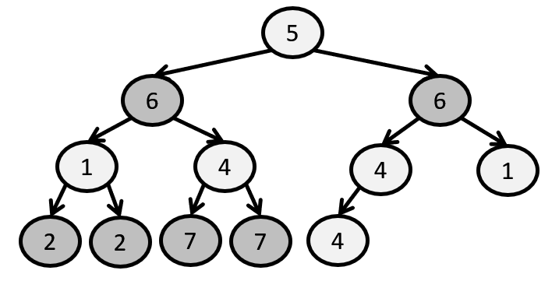  Test Case Input:  12  5  6 6  1 4 4 1  2 2 7 7 4 | 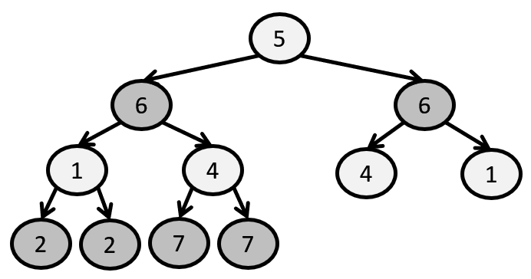  Test Case Output:  0  5  6 6  1 4 4 1  2 2 7 7
1 | Explanation of test case 1:  - The function returns false (0), the first line in the output, because siblings (1,4) are not equal and the (4,1) as well.  - Note that the last (4) is deleted because it does not have a sibling.
2 | 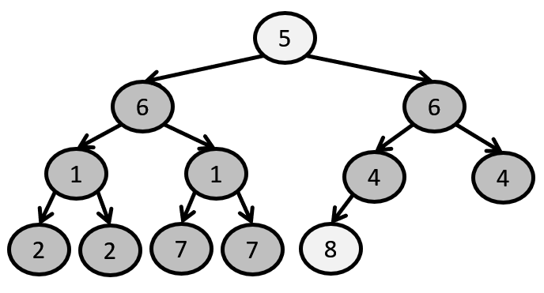  Test Case Input:  12  5  6 6  1 1 4 4  2 2 7 7 8 | 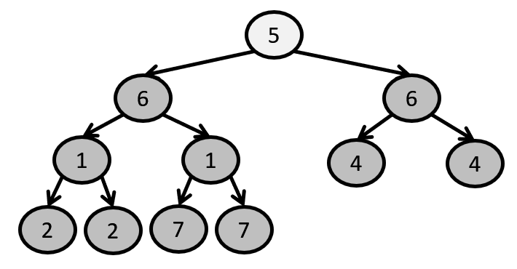  Test Case Input:  1  5  6 6  1 1 4 4  2 2 7 7
2 | Explanation of test case 2:  - The function returns true (1).  - Note that the last (8) is deleted because it does not have a sibling.

Problem 2:
Problem definition:
Given a complete tree, Write a recursive function “recMakeIdenticalThenFull” that takes another complete tree “tree2” and make the calling tree “tree1” identical to “tree2”. Then make “tree1” full tree by adding nodes with zero values.
Assume that all levels of “tree1” is identical in structure to all levels in “tree2” except the last level in “tree1” which contains less number of node than “tree2”.

- Use the given code in the attached file “Graded exercise4_Tree.cpp”.
- In the file, you will find the private recursive function recMakeIdenticalAndFull which use the following function header:
- static void recMakeIdenticalAndFull(TNode*& subRoot, TNode* subRoot2, int&
MaxLevel, int& PassingLevel)
and the corresponding public function that calls it “ void MakeIdenticalAndFull ()”.
- Remember that a Complete tree is a tree which all the levels except the last contains max num of nodes and the nodes in the last level are entered consecutive as left, right, left, and so on with no gaps).
- You are NOT allowed to use any auxiliary array-like or linked-list-like storage data structures, not even stacks, queues, nor “strings”.
- Manual penalty will be applied to your grade if you violated the above implementation constraints or the mentioned constraints in the attached code file.
- Check the following sample.

Sample:
1  6  5  4  tree1 |  | 1  -3  2  3  5  13  tree2
Test case input:  4  1  5 6  4  6  1  2 -3  3 5 1 | Explanation:  - Line 1 contains the number of nodes in tree 1and the following three lines contains the nodes’ values, level by level from left to right space separated, and a new line is inserted at the end of each level.  - Then line 5 contains the number of nodes in tree 2 and the following three lines contains the nodes’ values, level by level from left to right space separated, and a new line is inserted at the end of each level.
1  0  1  -3  2  3  5  tree1 |  | 1  -3  2  3  5  13  tree2
Test case output:  1  2 -3  3 5 1 0  1  2 -3  3 5 1 | Explanation:  - The first three lines contains the nodes’ values , level by level from left to right space separated, and a new line is inserted at the end of each level.  - Then the following three lines contains the nodes’ values, level by level from left to right space separated, and a new line is inserted at the end of each level.

Problem 3:
Problem definition:
Given a mathematical expression, write a recursive function “recBuildParseTree” to build the parse tree of this expression. The mathematical expression is fully parenthesized which means to use one pair of parentheses for each operator and the parentheses dictate the order of operations; so there is no ambiguity. The expression may contain one or more of the following mathematical operations (+, - , * , /).

- Take a copy of the given code in the attached file “Graded exercise4_Tree.cpp” and let the data be char not int. Change it in the setdata(…) and getdata()
- You may need to add additional pointer to the parent” TNode* parent” and set and get functions for that pointer.
- In the file, write the private recursive function recBuildParseTree which use the following function header:
static void recBuildParseTree (TNode* subRoot, string str, int& i)
and use the following corresponding public function that calls it “ void buildParseTree ()”.
void buildParseTree(string strr)
{
int index = 0;
root = new TNode('#');
recBuildParseTree(root, strr, index);
}

- Use the following main function:
int main()
{
// --- Note: Don't change the main function ----
string s;
cin >> s;
BinaryTree BT;
BT.buildParseTree(s);
BT.PrintTree();
// --- Note: Don't change the main function ----

return 0;
}

Sample:
Mathematical expression parse tree

5
*
-
+
7
3
2
Test case input:  ((7+3)*(5-2)) | Test case Output  *  + -  7 3 5 2
Test case input:  (3+(5*2)) | Mathematical expression parse tree  +  *  3  5  2  Test case Output  +  3 *  5 2

